Document #  [ID] | Title:  [Procedure Name] | Print Date:  [Date]
Revision #  1.0 | Prepared By:  [Author’s Name] | Date Prepared: [Date]
Effective Date:  [Date] | Reviewed By:  [Reviewer’s Name] | Date Reviewed:  [Date]
Standard:  [Standard, Law, or Regulation] | Approved By:  [Approver’s Name] | Date Approved:  [Date]
Policy: [What is the mission or standard that this SOP procedure must meet?]
Purpose: [What is the rationale of this SOP procedure?]
Scope: [What areas of the company are affected by this SOP procedure?]
Responsibilities:
[Who is listed in this SOP procedure and what are they required to do?]
[Who else is listed in this procedure and what are they required to do?]
[Who else is listed in this procedure and what are they required to do?]
Definitions: [What words are used in this procedure that readers may not understand?]
[What other words are used that readers may not understand?]
Procedure:

1.0 [First preparatory Activity - Plan]
  - [Who performs the first step of the activity and what do they do?]
  - [Who performs the second step of the activity and what do they do?]
  - [etc…]

2.0 [Second Activity - Do]
  - [Who performs the first step of the activity and what do they do?]
- [Use bullets to improve readability]
- [Use bullets to improve readability]
  - [Who performs the second step of the activity and what do they do?]
- [Use bullets to improve readability]
- [Use bullets to improve readability]
[NOTE: point out key elements. What forms are needed to capture what data?]
  - [etc…].

3.0 [Third activity – check]
3.1 [Who performs the first step of the activity and what do they do?]
3.2 [Who performs the second step of the activity and what do they do?]
- [Use bullets to improve readability]
- [Use bullets to improve readability]

4.0 [Fourth activity – act]
4.1 [Who performs the first step of the activity and what do they do?]
4.2 [Who performs the second step of the activity and what do they do?]
  - [etc…]

5.0 [Use more activities as needed]
5.1 [Who performs the first step of the activity and what do they do?]
5.2 [Who performs the second step of the activity and what do they do?]
Effectiveness Criteria:
- [What measures communicate the procedure is working?]
- [What records are required to be completed?]
References:

A. [Standard, law or regulation]
Paraphrase what this standard, law or regulation says.

B. [Other Procedures, documents, RECORDS, etc]
Paraphrase what this reference is about.
Forms/Records:
Form # | Record/Form/Activity Name | Satisfies Clause
Required by Standard
XXXXX | Record
Other Forms/Records
XXXXX | Record
XXXXX | Record
XXXXX | Record
Process Map:
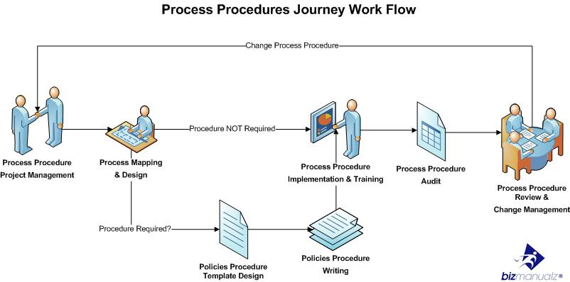
Revision History:
Revision | Date | Description of changes | Requested By
0.0 | [Date] | Initial SOP Release

